GUIDELINES TO APPLICATION FOR VSAT LICENCE FOR
CORPORATE COMMUNICATION

1 Introduction

1.1 The licensing framework for parties who wish to establish VSAT (Very Small Aperture Terminal) networks and links varies, depending on the purpose and precise scope of the VSAT network and links, as outlined below:

- VSAT networks and links for own use, i.e. for intra-corporate communication (i.e. between holding companies and subsidiaries); communication between related companies; and between companies that have established business relationships with one another; or

- VSAT networks and links for provision of telecommunication services to third parties.

2 Definition
2.1 For the purpose of the VSAT Licence, the following terms shall have the meanings ascribed hereto:

2.1.1 “Licensee” refers to a person, firm, limited liability partnership or corporation who is licensed to install and operate VSAT facilities for corporate communication traffic.

2.1.2 “Corporate Communication” refers to communication between the following entities:
- Holding companies and their subsidiaries;
- Related companies; and
- Corporations which have established business relationships with one another.

The terms “Holding companies”, “Subsidiaries” and “Related companies” shall have the same meanings ascribed to them in the Companies Act (Cap. 50).

2.2 With regard to 2.1.2(c), a corporation which does not have any shareholding interest in another corporation shall nonetheless be deemed to have an established relationship with that other corporation if there is an existing business relationship established through a consistent course of dealings between the two corporations.
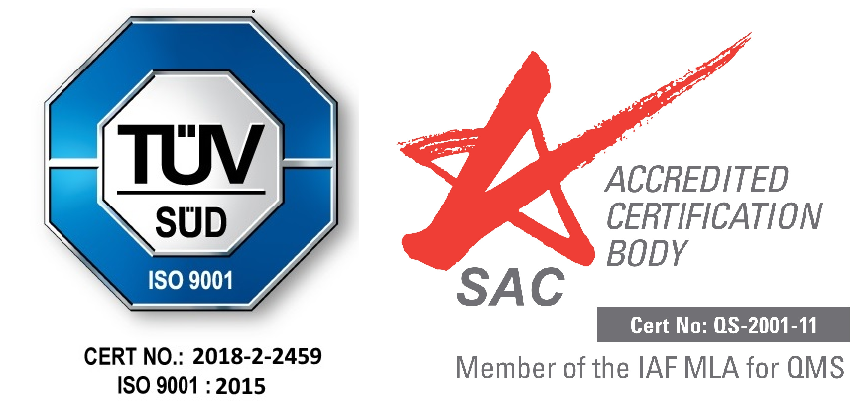

Such relationships would include, but not be limited to customer, supplier or distributor relationships. IMDA would also allow VSAT links to be established between entities for reasons other than for commercial purposes (e.g. R&D) provided that the applicant can prove that:

- It has the intention of establishing a relationship with the other party for a reasonable period of time;

- The VSAT link is necessary to meet the applicant’s specific communication requirement; and

- The VSAT link will be used for the carriage of the applicant’s own traffic and not for communication between third parties.

3 Scope VSAT Licence for Corporate Communication

3.1 Companies that wish to establish VSAT networks and links for their own use need to apply for a VSAT Licence. The Licence will allow the Licensee to use VSAT networks for Corporate Communication between holding companies and subsidiaries; between related companies; and between companies that have established business relationships with one another only.

3.2 The VSAT links must be used for conveyance of the Licensee’s own traffic only and not that between third parties, the provision of public telecommunication services here via these VSAT links is strictly prohibited. While different licensees may share the use of a VSAT dish, each individual licensee must gain access via different space segments as well as separate cabling to and from the shared VSAT antennae.

3.3 The Licensee is allowed to receive telecommunication signals from a satellite to a VSAT satellite dish in Singapore (downlink) and/or to transmit signals from a VSAT satellite dish in Singapore to the same satellite or a different satellite (uplink). The scope of service only covers the reception and/or transmission of telecommunication signals. The reception and/or transmission of publicly subscribed satellite television and/or sound broadcast signals through the VSAT system are strictly prohibited.

4 For Provision of Telecommunication Services to Third Parties

4.1 Companies that wish to use the VSAT networks and links for provision of telecommunication services to third parties would need to apply for a Services-Based Operator (SBO) (Individual) Licence. The SBO (Individual) Licence will allow Licensees to use the VSAT links to provide telecommunication services to customers and carry third party traffic. Licensees here would also be allowed to interconnect any public telecommunication networks at both ends.

5 Description of System

5.1 The Licensee shall maintain and operate a system comprising a VSAT satellite dish, the VSAT station and associated equipment as authorised in writing by IMDA.

5.2 The VSAT dish and associated equipment shall be installed and operated from the VSAT end-users premises in Singapore.

5.3 The Licensee would have the option to purchase their space segments from any Facilities-Based Operator (FBO), any SBO licensed by IMDA to provide space segment capacities or any other satellite operators.

6 Compliance with Regulatory Framework

6.1 The Licensee shall provide information as requested by IMDA from time to time in connection with this Licence.

6.2 The Licensee shall be obliged to comply with the technical standards set by IMDA which shall include ensuring that the VSAT facility does not interfere with other communication systems or services.

7 Prior Clearance with other Relevant Authorities

7.1 For trans-border communication using VSATs, the applicant should obtain the necessary approvals and consent from the relevant authorities at the respective destination countries. The Licensee shall be solely liable for any damage/loss resulting from the termination of the VSAT link(s) due to any from any overseas authority.

7.2 The applicant is required to seek the necessary clearance from other relevant authorities in Singapore concerning the setting up of VSAT facilities. These authorities may include, but is not limited to Development Control Division of Urban Redevelopment Authority (URA) and Building Control Division of Building & Construction Authority (BCA).

7.3 VSAT dishes erected on ground will be exempted from approval by the URA and BCA. VSAT dishes located at rooftops, will also be exempted from approval by URA and BCA if the diameter is 5.0m or less. The applicant is advised that URA will not accept objections to subsequent developments in the neighbourhood that may result in the blockage of wave/transmission paths.

7.4 Formal approvals from the relevant authorities, including authorisation of companies in the VSAT network outside of Singapore, must be obtained prior to submitting application for VSAT Licence to IMDA for consideration.
8 Suitability of Sites

8.1 The applicant is responsible for making sure that the site proposed for the VSAT satellite dish is suitable for the operation of the facility.

8.2 In instances where the VSAT dish cannot be erected on the rooftop of the Licensee’s premise, IMDA can approve, on a case-by-case basis, the installation of the antennae at a remote site provided that the VSAT dish is used solely by the Licensee and that the owner of the proposed remote site allows the installation of the VSAT dish.

9 Licence Duration and Fees

9.1 The duration of the Licence will be for a period of 3 years, subject to renewal on a 3-yearly basis. An annual licence fee of $100 per VSAT station is payable, as specified in the FIRST SCHEDULE (Part II) of the Telecommunications (Radio-communication) Regulations, 2001.

9.2 For the use of VSAT networks and links for provision of telecommunication services to third parties under the SBO (Individual) Licence, the duration of the Licence will be for a period of 5 years, subject to renewal on a 5-yearly basis. The annual licence fee payable shall be a minimum sum of $4,000 for Annual Gross Turnover (“AGTO”) of less than $50 million. An annual licence fee of $100 per VSAT station is also payable, as specified in the FIRST SCHEDULE (Part II) of the Telecommunications (Radio-communication) Regulations.

Note:
Licence fees paid shall not be refunded (whether on a pro-rated basis or any other basis) in the event that the licence is cancelled by IMDA in the following circumstances:

- where the licensee requests for variation or early termination of its licence, or

- where IMDA cancels the licence under Section 8 of the Telecommunications Act (Cap 323).

10 SATELLITE COMMUNICATION STATION LICENCE & FREQUENCY

10.1 Applications must also apply for a Satellite Communication Station Licence for the establishment and operation of a satellite communication station in Singapore. Applicants should submit their licence application via online business licensing service at https://licence1.business.gov.sg/web/frontier/home.

10.2 Applicants should note that frequency fees are separately payable to IMDA for the allocation and management of frequencies.

10.3 Applicants are advised to take appropriate measures such as installing filters in their receiver system to mitigate potential interference from other services.

11 Application Procedure

11.1 Interested parties who wish to apply for the VSAT Licence should submit their application via IMDA’s Telecoms Licensing System at https://licence1.business.gov.sg/web/frontier/home.

12 Enquiries

12.1 For enquiries, please contact Mr Benjamin Kong at Tel: 6202 4366.

Notes:

1 This document has no legal standing and is not intended as a substitute for legal advice. While every effort has been made to provide an accurate and authoritative account of the licensing regime, the licence(s) to be granted to successful applicants will be the complete authoritative text.

2 The information contained in this document is intended to assist interested parties in applying for the relevant licences. It does not bind IMDA to any particular course of action in relation to the handling of any application, or to the terms of any licence to be granted, or to grant any licence to any party. IMDA reserves the right to change its policies and/or to amend this document without prior notice.

3 The grant of a licence is at the sole discretion of IMDA. IMDA reserves the right not to accept any application submitted. IMDA will undertake to explain to the applicant concerned, on the applicant’s request, why the applicant is unsuccessful in its application for a licence.

4 IMDA reserves the right to disclose the identities of parties who have submitted applications. All other information received will be treated in confidence.

IMDA will accept applications from foreign companies registered under the Singapore Companies Act, Chapter 50.
For this purpose, companies should apply IMDA for the relevant TVRO Licence
For AGTO amount between $50 million - $100 million, 0.5% of such amount in excess of $50 million is computed as part of the licence fee payable. If the AGTO amount is more than $100 million, another 0.8% of such amount in excess of $100 million is calculated and formed part of the total annual licence fee payable for that financial year.

