FACTSHEET

**LAUNCH OF THE PRECISION ENGINEERING INDUSTRY DIGITAL PLAN**

**Background**

The Precision Engineering (PE) sector is one of the key pillars in Singapore’s manufacturing ecosystem, with SMEs making up 92% of the sector consisting of more than 2,700 companies. Employing a workforce of over 101,000, they supply precision parts and components, as well as machinery and complex equipment to support the manufacturing processes of a range of industries such as aerospace, automotive, electronics, medical technology and semiconductors.

To ensure the continued growth of Singapore’s key manufacturing pillar, the PE industry aims to establish an ecosystem of new generation PE enterprises that leverage digital manufacturing technologies and platforms to innovate and deliver competitive products/services for global markets.

**Precision Engineering Industry Digital Plan**

The PE Industry Digital Plan (IDP) is part of the SMEs Go Digital programme that aims to make going digital simple for SMEs.

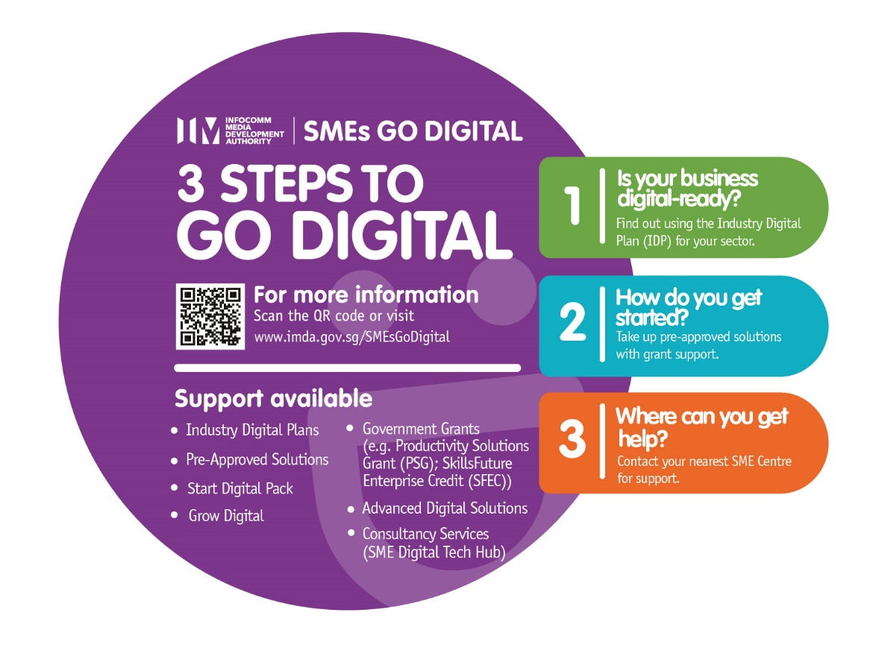

The Infocomm Media Development Authority, in partnership with Enterprise Singapore and the industry, jointly developed the PE IDP to guide SMEs on their digital transformation efforts, by providing an easy-to-use, step-by-step guide on the digital solutions to adopt at each stage of their growth.

Central to the IDP is the Digital Roadmap that guides SMEs in the sector towards a better understanding of their digital readiness, the solutions available and the training required to raise their employees’ digital capabilities.

The IDP will be reviewed and updated regularly with the latest digitalisation advancements in the sector as new technologies are being introduced gradually.

**Components of the PE IDP**

1. **Digital Roadmap**

The three-stage digital roadmap of the IDP charts out the digital solutions that enterprises in the PE industry can adopt at each stage of their growth to support their digital journey.

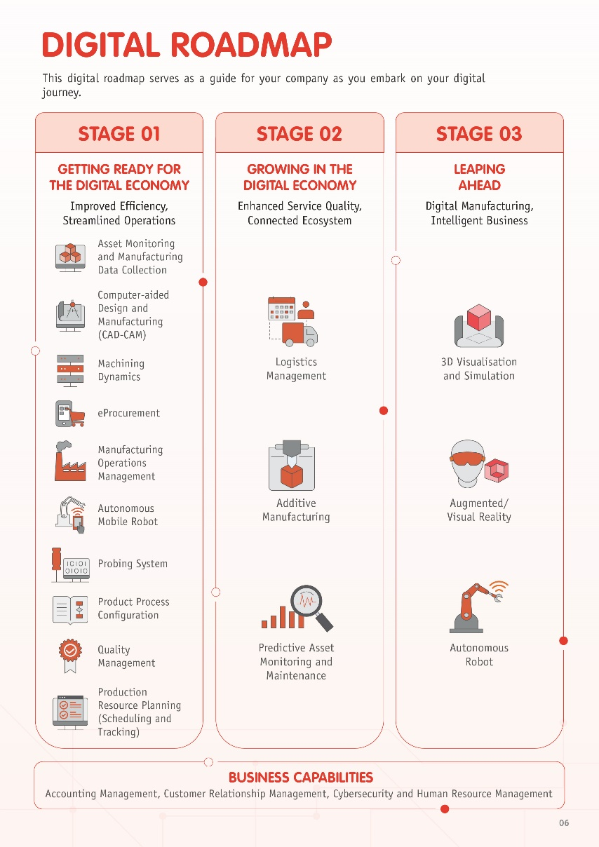

* 1. **Stage 1: Getting Ready for the Digital Economy.** The initial stage aims to help SMEs get ready for the digital economy with basic solutions to kickstart their digital journey. The objective is to streamline/integrate business operations, provide higher-value work, build core digital capabilities and enhance operational productivity
  2. **Stage 2: Growing in the Digital Economy.** The second stage highlights digital solutions that enable SMEs to connect digitally and innovatively to optimise business value.
  3. **Stage 3: Leaping Ahead.** The third stage recommends advanced digital technologies that SMEs can adopt to anticipate potential operation pitfalls and put in place mitigation plans to manage project risks. Adoption of these digital technologies will help business to achieve automated operations and optimise towards being a smart business.

1. **Digital Training Roadmap**

The IDP also includes a Digital Training Roadmap to guide the industry in preparing their workforce with the necessary skills to adopt digital solutions, so that they are ready for changes that come with digital transformation.

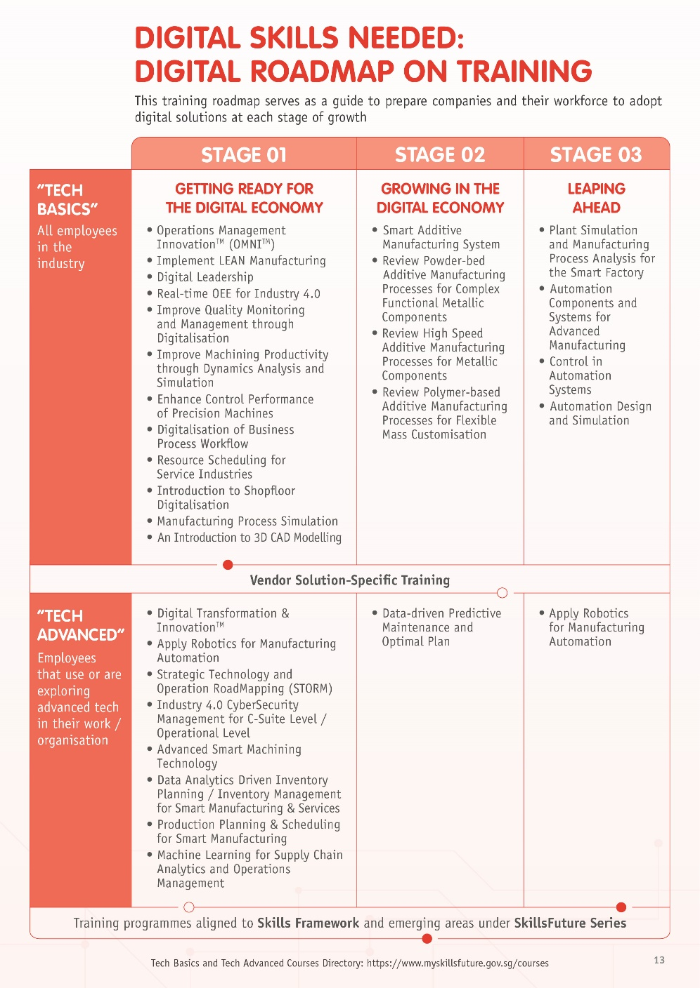

1. **Online self-assessment checklist**

SMEs can use the online self-assessment checklist to assess their digital readiness and identify opportunities to go digital based on their current business operations, level of digitalisation and business expansion plans. For more information, visit www.imda.gov.sg/SMEsGoDigital.

1. **Tapping expertise of partners**

SMEs can approach **Business Advisors at their nearest SME Centre**[1] for business diagnosis and advisory on digital solutions relevant to their operations. SMEs that require specialist consultancy on sophisticated technologies, such as data analytics and cybersecurity, can engage principal consultants at the SME Digital Tech Hub **under the SMEs Go Digital programme** [2]. These digital consultancy services are provided at no cost to SMEs.

**Further support under SMEs Go Digital**

1. **Pre-Approved Solutions**

To make it easy for SMEs to adopt the digital solutions recommended in the PE IDP, IMDA provides a list of pre-approved solutions assessed to be market-proven, cost-effective and supported by vendors appointed by IMDA. SMEs can visit GoBusiness Gov Assist (<https://govassist.gobusiness.gov.sg/productivity-solutions-grant/>) for the contact information of the pre-approved solution providers. If funding support is required, SMEs can apply for the Productivity Solutions Grant (PSG) on the Business Grants portal, before purchasing and implementing digital solutions.

SMEs can also participate in digital sector projects that are initiated jointly by IMDA and industry leaders. Such projects pilot new digital solutions or platforms that have the potential to uplift the whole sector.

1. **Start Digital**

SMEs that have just started their businesses or are new to digital technology, can tap on the Start Digital Pack to start their business right with foundational and competitively-priced digital solutions. These solutions cover: Accounting, Human Resources Management & Payroll, Digital Marketing, Digital Transactions and Cybersecurity. SMEs can take up any two solutions and receive cost waivers for at least six months when they sign up for a minimum 18-month contract. The solutions are pre-approved by IMDA and offered by Start Digital Partners like DBS, M1, Maybank, OCBC, Singtel and UOB. More information available here: [www.imda.gov.sg/startdigital](http://www.imda.gov.sg/startdigital)

1. **Grow Digital**

For SMEs that are ready to seize business opportunities in overseas markets, they can tap on Grow Digital to get a head start in going global. It connects SMEs to Business-to-Business (B2B) and Business-to-Consumer (B2C) e-commerce platforms. Pre-approved by IMDA and ESG, these platforms have good track record and operating experience in multiple markets with regional or global reach, strong networks with complementary business service providers (e.g. logistics and financing).

1. **Advanced Digital Solutions**

SMEs can also receive funding support to adopt advanced and integrated solutions[3] to improve their business resilience and long term competitiveness.

1. List of SME Centres can be found at [www.enterprisesg.gov.sg/smecentre](http://www.enterprisesg.gov.sg/smecentre).
2. For more information, please refer to [www.digitaltechhub.sg](http://www.digitaltechhub.sg).
3. For more information, visit: [www.imda.gov.sg/advanceddigitalsolutions](http://www.imda.gov.sg/advanceddigitalsolutions)