**New digital plan to help Precision Engineering industry digitalise and build capabilities for the future**

*About 2,700 businesses expected to benefit from the guide rolled out by Enterprise Singapore and IMDA*

MR No.: MR97/21

Singapore, Tuesday, 23 November 2021

1. About 2,700 businesses and 101,000 employees can now tap the **Precision Engineering Industry[1] Digital Plan (IDP)** to drive productivity and transform through digitalisation**.** Jointly led by Enterprise Singapore (ESG) and the Infocomm Media Development Authority (IMDA), in partnership with the Singapore Precision Engineering & Technology Association (SPETA), the IDP was launched by Mr Alvin Tan, Minister of State for Trade and Industry, at the Industrial Transformation Asia-Pacific event. The IDP aims to help PE enterprises assess their digital readiness and identify suitable digital solutions to accelerate their growth.
2. The IDP comprises two roadmaps:
   * the **Digital Roadmap** maps out different digital solutions that SMEs can adopt at different stages of their busines growth and digital maturity; and
   * the **Digital Training Roadmap** offers a corresponding roadmap of training programmes to equip employees with the right skillsets.
3. SMEs that have adopted such digital solutions saw improved efficiency and better optimisation of resources (refer to Annex B for company examples).

**A step-by-step guide on how PE companies can go digital**

1. As part of the SMEs Go Digital Programme[2], the IDP provides a guide on the digital solutions that SMEs can adopt at three stages of growth:

* **Stage 1** gets SMEs ready for the digital economy and lists the basic digital solutions that help streamline and integrate businesses operations to improve efficiency. Examples include solutions in manufacturing operations management, automated mobile robot and production resource planning. These allow enterprises to reduce human errors and enable employees to focus on higher-value work such as developing new and better-quality products for their clients.
* **Stage 2** provides digital solutions for SMEs that are ready to scale their transformation efforts, enabling them to integrate their current workflow and production processes to optimise business value. An example is the predictive asset monitoring and maintenance system, which tracks and forecast the overall performance of equipment and machines. This not only helps businesses plan and detect potential faults early; it reduces maintenance costs and the need to stock additional spare parts.
* **Stage 3** identifies advanced technologies that SMEs can adopt to drive smart manufacturing. For instance, autonomous robot can automate high-volume and repetitive tasks such as assembling of product components as well as lifting and moving of heavy items. This reduces margins of error and risk of workplace accidents, and provides employees the opportunity to take on higher-value roles.

1. Ms Anne Ho, ESG’s Director for Advanced Manufacturing said, “The Precision Engineering industry is being disrupted by new digital manufacturing technologies, rising competition, as well as shifts in consumer demand and supply chains. This has accelerated the push for PE enterprises to digitalise, not just to drive higher productivity, but also to transform and innovate in order to adapt to the evolving business environment. Digital technology will enable our SMEs to operate more efficiently and make data-driven decisions to fuel their growth plans. This IDP can help companies kickstart their digital journey and take their transformation to the next level.”

1. Ms Catherine Chong, IMDA’s Director for SMEs Go Digital said, “We encourage SMEs of varying business needs and digital readiness to tap on digital solutions in PE IDP to optimise their business operations as well as deliver better quality customised products and services to their customers. The PE IDP will guide SMEs to be more confident in using digital solutions such as Manufacturing Operations Management and Production Resource Planning as a start to achieve operational efficiency and build core digital capabilities.”

**Self-assessment tool and training roadmap**

1. Enterprises can use an online self-assessment checklist to help them assess their digital maturity and readiness, as well as identify gaps in their current digital capabilities. The checklist takes into consideration factors such as the current business operations, stage of digitalisation and business expansion plans. This is accessible at [self-assessment checklist](https://smedigitalisationstudy.experian.com.sg/self-assessment/precision-engineering).
2. Continuous workforce upskilling is key in ensuring that employees remain relevant in tandem with the company’s digitalisation journey. Under the Digital Training Roadmap, companies can plan their training programmes based on the needs of employees as well as at each stage of their transformation. These training programmes are aligned to the Skills Framework developed for the sector. SMEs can visit GoBusiness Gov Assist[3] for the list of pre-approved solutions under the IDP that are supported by the Productivity Solutions Grant (PSG).

**Annex A: Infographic of the Digital Roadmap for Precision Engineering Industry and Digital Training Roadmap**

**Annex B: Details on the digitalisation efforts by selected Precision Engineering companies**

-End-

For media enquiries, please contact:

**Enterprise Singapore**

Ms Karen Koh   
Business Partner, Corporate Communications

M : + 65 9889 8816

E : [Karen_Koh@enterprisesg.gov.sg](mailto:Karen_Koh@enterprisesg.gov.sg)

**Infocomm Media Development Authority**

Ms Bridget Chang

Manager, Communications and Marketing, IMDA

M : + 65 8118 2764

E : [Bridget_CHANG@imda.gov.sg](mailto:Bridget_CHANG@imda.gov.sg)

**About Enterprise Singapore**

Enterprise Singapore (ESG) is the government agency championing enterprise development. We work with committed companies to build capabilities, innovate and internationalise.

We also support the growth of Singapore as a hub for global trading and startups, and build trust in Singapore’s products and services through quality and standards.

Visit [www.enterprisesg.gov.sg](http://www.enterprisesg.gov.sg) for more information.

**About Info-communications Media Development Authority (IMDA)**

The Infocomm Media Development Authority (IMDA) leads Singapore’s digital transformation with infocomm media. To do this, IMDA will develop a dynamic digital economy and a cohesive digital society, driven by an exceptional infocomm media (ICM) ecosystem – by developing talent, strengthening business capabilities, and enhancing Singapore's ICM infrastructure. IMDA also regulates the telecommunications and media sectors to safeguard consumer interests while fostering a pro-business environment, and enhances Singapore’s data protection regime through the Personal Data Protection Commission.

For more news and information, visit [www.imda.gov.sg](http://www.imda.gov.sg) or follow IMDA on Facebook IMDAsg and Twitter @IMDAsg.

**ANNEX A**

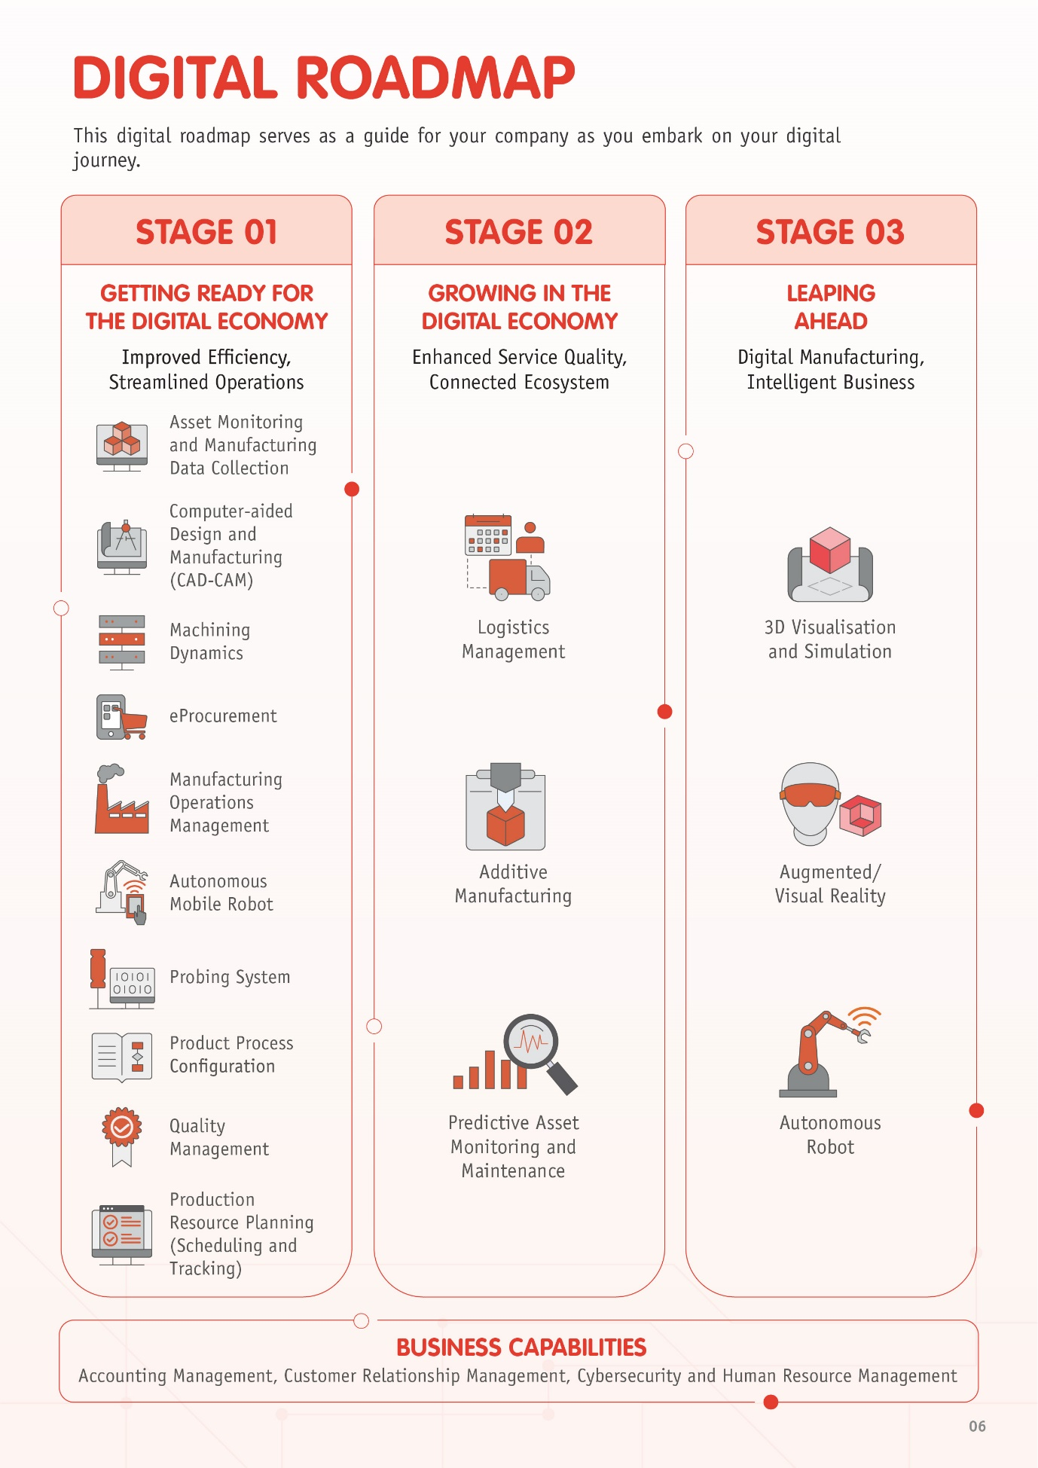

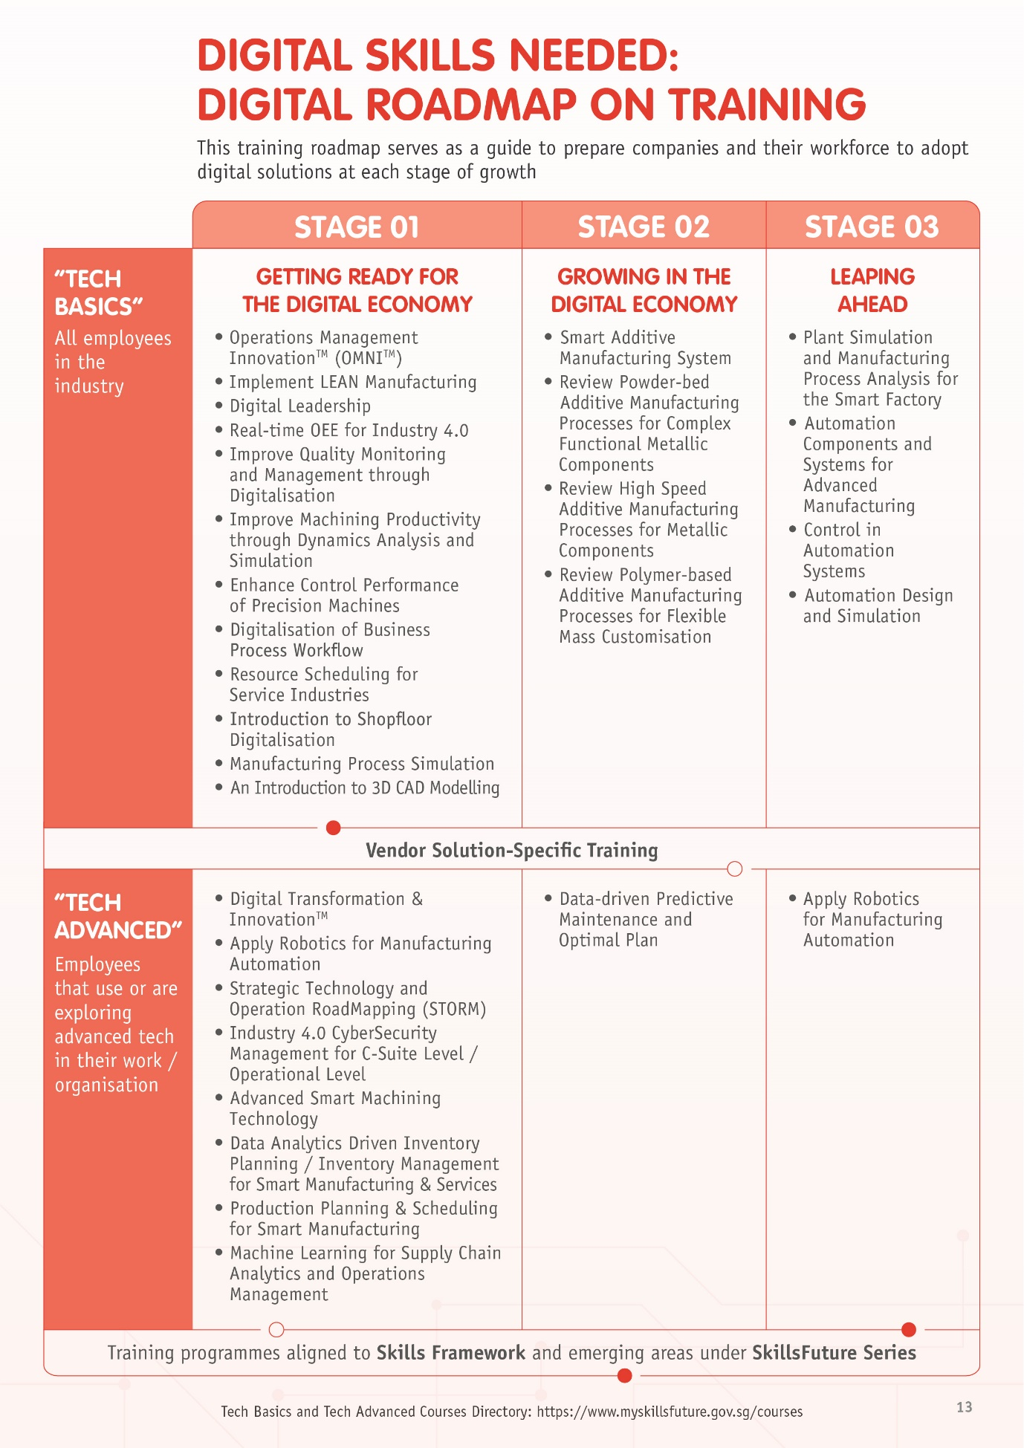

**ANNEX B**

**Certact Engineering Pte Ltd**

Established in 1968, Certact Engineering Pte Ltd is a precision engineering company that provides manufacturing services for sectors such as semiconductor and medical technology. They make components using CNC milling, turning, grinding and wire cutting processes. The company has also ventured into the plastic engineering industry to provide a range of plastic fabrication services such as thermo-forming and plastic welding.

With the support from ESG, Certact is embarking on their digitalisation journey through deploying robotics cells with conveyor systems to automate their machine tending process. This will replace the current manual machine tending process, connecting its equipment and machines across the network to enable quick uploading of the CNC programmes. The company also introduces IoT solutions to extract real-time production floor data to improve their decision-making process. This has enabled the company to become more manpower efficient, saving about seven man-hours per employee and S$600 in labour costs per CNC machine each month.

The company also has plans to deploy further robotics cells and automated solutions as they look to expand its manufacturing capacity to meet the increasing demand.

**Koei Tool Singapore Pte Ltd**

Established in 1989, Koei Tool Singapore is a tooling company that specialises in injection moulding. With effective use of 3D printers, Koei Tool can also mould parts that traditional metal cutting cannot achieve.

Since 2019, Koei Tool has embarked on their digital transformation, where they deployed robotics and software deployment solutions to digitalise and automate part of its mould manufacturing process. The company has also adopted a Design and Computer-aided Manufacturing (CAM) software to increase their company’s capability in pre-preparing work processes. This has enabled each programmer to produce up to 150 to 200 programmes per year, as compared to 40 to 50 programmes in the past.

The company has greatly benefitted from the transformation, especially in the current pandemic. During the Circuit Breaker period, the company was able to devise a new production plan quickly that allowed them to run their operations with employees monitoring the machines from home. In addition, the improved productivity has enabled Koei Tool’s local operations to take on additional manufacturing orders from its other overseas manufacturing sites.

With the support from ESG, the company is currently deploying more i4.0 solutions, such as robotics solutions and Manufacturing Execution System (MES), across its manufacturing lines and processes. The deployment is expected to reduce manpower requirements by another 20%, enable real-time monitoring of the production process, product quality and delivery schedule.

**Onn Wah Tech Pte Ltd**

Founded in 2008, Onn Wah Tech Pte Ltd (OWT) is a subsidiary of Onn Wah Precision Engineering, which provides solutions for the precision tooling market.

Since 2017, OWT has kickstarted their digitalisation journey by deploying a Manufacturing Execution System that can connect and monitor machines on the factory floor. The company has also deployed an Overall Equipment Effectiveness (OEE) system to eliminate manual data recording and compilation. These solutions allow OWT to capture and track data from individual machines or work centres, which help the management make more effective business decisions.

During the pandemic, the company also shifted some of their equipment to their employees’ home. These equipment are connected to the office’s server, which help employees to better support product design remotely.

With ESG’s support, the company is currently working with Singapore Polytechnic to automate the design generation process via a design template, which automatically generates the 3D model of a precision component that will be manufactured.

1. The PE industry is one of the key pillars in Singapore’s manufacturing ecosystem. It plays a crucial role in supply precision parts and components, as well as machinery and equipment to support and improve manufacturing processes.
2. SMEs Go Digital, launched in April 2017, is a whole-of-government programme that aims to help SMEs use digital technologies, build strong digital capabilities and participate in the Digital Economy. More information can be found at [www.imda.gov.sg/SMEsGoDigital](http://www.imda.gov.sg/SMEsGoDigital).
3. GoBusiness Gov Assist is a one-stop, centralised platform aimed at improving SMEs’ access to technology and digital solutions. SMEs can visit <https://govassist.gobusiness.gov.sg/productivity-solutions-grant/> for more information.