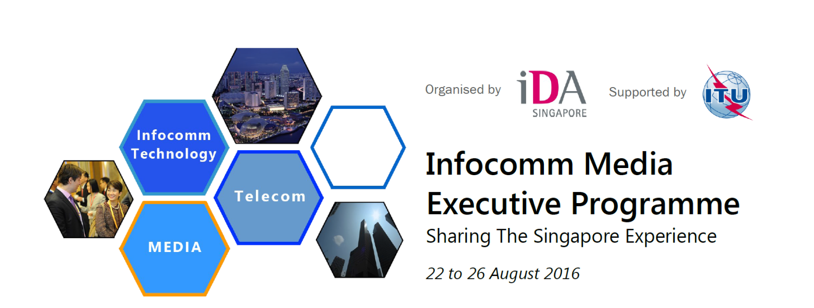

Infocomm Media Executive Programme 2016
Sharing The Singapore Experience
Thank you for your interest in the Infocomm Media Executive Programme 2016.
1. The application deadline is 10 July 2016.
3. Please apply early as seats are limited.
4. Confirmation of registration can only be given upon receipt of full payment.
5. Kindly scan and submit completed form and/or email any enquiries to (Ms) Angela Tey at Angela_Tey@ida.gov.sg and
(Mr) Adrian Tan at Adrian_TS_Tan@ida.gov.sg and copy IDA_IR@ida.gov.sg.
* Field marked with (*) are mandatory fields.
^"NIL" or "N/A" should be used where applicable.
Applicant's Particulars

First Name* | Click here to enter text.
Last Name (Family Name)* | Click here to enter text.
Gender* | Choose an item.
Nationality* | Click here to enter text.
Country of Birth | Click here to enter text.
Passport Number* | Click here to enter text.
Passport Expiry Date | Click here to enter text. (YYYY-MM-DD)
Food Preference | Choose an item. Others: Click here to enter text.

Contact Details

Business Address | Click here to enter text.
Mobile Number* | Click here to enter text.
Email Address* | Click here to enter text.  ☒ I wish to receive email updates from IDA and the respective events Alumni.
Emergency Contact* | Name : Click here to enter text.  Mobile Number : Click here to enter text.  Relationship : Click here to enter text.  Address : Click here to enter text.  Email : Click here to enter text.

Employment Details

Organization* | Click here to enter text.
Representing Government of (Country)* | Click here to enter text. (Enter Country Name)
Years at present organization | Years Months
Designation* | Click here to enter text.
Department | Click here to enter text.
Brief Job Description* | Primary scope  Secondary scope
Objectives of Attending the IMEP 2016

Others
Course fee | USD 4,300 per person  Note: Fees include classroom sessions, programme documentation, lunches and refreshments as well as any social programmes. Participants will have to bear the cost of their own airfare, airport transfers, hotel accommodation and bank transfer charges. Payment is to be made in US Dollars. Confirmation of registration can only be given upon receipt of fully payment.
Confirmation of Application | Signature of Applicant: Date:

Kindly scan and submit completed form and/or email any enquiries to (Ms) Angela Tey at Angela_Tey@ida.gov.sg and
(Mr) Adrian Tan at Adrian_TS_Tan@ida.gov.sg and copy IDA_IR@ida.gov.sg.

