DIGITAL MAKER PROGRAMME

APPLICATION FORM

Name of School :
(only Government, Government-aided, Specialised Independent and Independent schools are eligible)

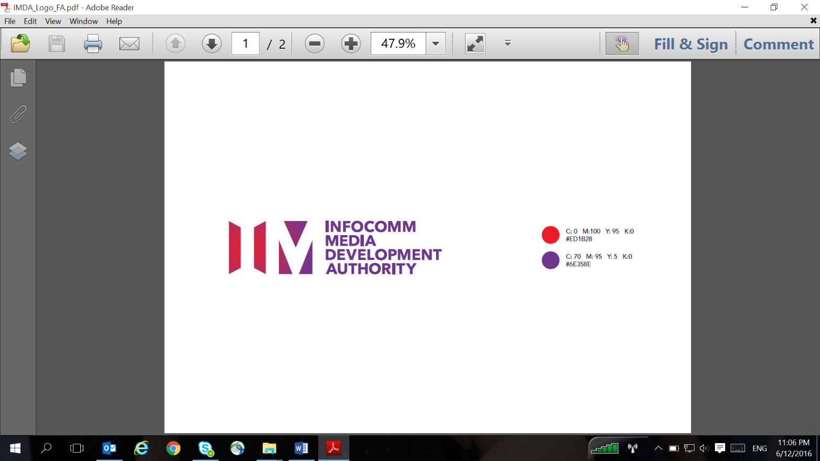
Info-communications Media Development Authority of Singapore (“IMDA”)

10 Pasir Panjang Road
#10-01 Mapletree Business City
Singapore 117438
Tel : (65) 6211 0888
Fax : (65) 6211 2222

Website : www.imda.gov.sg

For Official Use :

Approved / Not Approved

__________________________ ______________
Name & Signature Date
ALL INFORMATION PROVIDED WILL BE
HELD IN STRICTEST CONFIDENCE

USEFUL NOTES

- Registration
To assist us in evaluating your registration speedily, please provide the requested information as completely and accurately as possible. If the space provided is insufficient, a separate sheet may be used. Where information is not yet available or not applicable, please indicate accordingly.

You are advised to contact us should you have any difficulties in completing the form or if you need any further information. Please drop us an email at Digital_Maker@imda.gov.sg should you have any queries.

Only one copy of this registration form needs to be submitted. Please email the scanned copy to: Digital_Maker@imda.gov.sg.

- Structure of the Registration Form
The registration form consists of 3 parts:
Part A : School’s Declaration
Part B : Programme Information
Part C : School’s Information

PART A – SCHOOL’S DECLARATION
- I declare that _______________________________________________ [Name of School] (from now on referred to as “the school”) is a/an Government/Government-aided/ Specialised Independent and Independent schools (please delete accordingly) school and is interested to participate in the Digital Maker Programme.
- I declare that the information provided by me in this application and the accompanying documents are true and accurate to the best of my knowledge.
- I agree that IMDA shall have the absolute discretion to accept or reject any application made without being liable to give any reason thereof. I understand that if the school obtains the offer by false or misleading statements, IMDA may withdraw and recover immediately from the school any Digital Maker technologies that may have been distributed.
- I confirm that I am involving teachers and students of the school on the volition of the school and the school shall not hold the IMDA, its partners and organisers responsible or in any way liable for any personal injury, death, and/or any other direct, indirect or consequential misfortune/accident/loss/damage/loss of profits/economic loss whatsoever arising from any cause in connection with the Digital Maker Programme/trainings/activities.
- I confirm that the school will undertake proper care and maintenance of the Digital Maker technology, namely micro:bits, to ensure that they remain in good working condition for the programme period.
- I confirm that the schools will keep track and be accountable for the Digital Maker technology that has been given to the school.
- I confirm that IMDA shall not be obliged to provide any replacements for any part of the Digital Maker technologies if any items are faulty or not in good working condition or lost unless the six (6)-month warranty period for the Digital Maker technology is still valid.
- I agree to share and provide updates on the activities carried out by the school under the Digital Maker Programme and teacher / student participation rates as may be requested by IMDA.
- I agree to submit at least one lesson plan with the use of the Digital Maker technology within six (6) months from the date of the teacher training, outlining the use of the Digital Maker technology for a subject or school programme for sharing with the larger education community.
- I agree to provide IMDA with documentations as may be requested by IMDA for the purpose of verifying compliance.

______________________________ ____________________________
Signature of Principal School Stamp [Name of School]

____________________________ ____________________________
Name (in BLOCK LETTERS) Date

PART B – PROGRAMME INFORMATION

- INTRODUCTION

The Digital Maker programme aims to nurture a new generation of digital natives. The objectives are to empower our students and adults to be digital creators and makers, so as to cultivate real-world problem solving, encourage digital creativity and innovation, as well as foster collaboration and co-creation with fellow Digital Maker.

- SCOPE OF PROGRAMME

2.1. IMDA will provide free micro:bits for up to one level of students for all schools that sign up for the Digital Maker programme (about 300 per school). Schools can determine which level(s) they would like to introduce it to (e.g. to rotate across levels each term) and how they may want to use it (e.g. for their Science, Design and Technology lessons or Applied Learning Programmes).

2.2. There will be 4 rounds of sign-ups over the 2 years. There will be publicity and communications made to schools to inform them of the next upcoming sign-up exercise. The deadline for the 1st round of sign-up is 8 May 2017.

2.3. After the schools have signed up for the Digital Maker programme, they can send up to 5 teachers for a 1.5-day workshop. The workshop will be a mix of seminar-style sharing and hands-on activities, covering basic concepts on how to create simple products, and the possible use of the Digital Maker technology in a few subjects.

- FUNDING & TRAINING SCHEDULES

  - The micro:bits and the training for 5 teachers per school will be fully funded by IMDA and Microsoft respectively. Schedule of the training sessions can be found under Part C of this form. Teachers will go through 1.5-day training session (Day 1 session from 9-4pm at Microsoft & Day 2 session from 9-12pm at Home-Fix XPC). Each training session can only accommodate up to 50 participants and it will be on a first-come-first-serve basis. Upon receiving this application form, the IMDA officer will evaluate the application and confirm the training details with the school if the application is approved. In the event that there is any change to the training timeslots, please inform the IMDA officer at Digital_Maker@imda.gov.sg no later than 15 May 2017. If the notification is later than this date, we may not be able to accommodate the request.

Training Venues:
Microsoft Auditorium – 1, Marina Blvd, Level 22, S018989
and
Home-Fix XPC – 19, Tai Seng Avenue, Level 5, Home-Fix Building, S534054

- DELIVERABLES

4.1. Schools that sign up for the programme will be requested to contribute at least one lesson idea from each school. Selected ideas will be shared on the public Digital Maker portal. Schools will also be invited to showcase their teachers’ and/or students’ works at events that IMDA and Microsoft will be organising.

- BRANDING & PUBLICITY FOR SCHOOLS

5.1. Participating schools will be listed on IMDA’s websites and publicity materials as a Digital Maker school.

PART C – SCHOOL’S INFORMATION

Name of School:

Primary School Secondary School

(Please √ accordingly)
Address: |  |  | Postal Code:
Tel: | Fax: | URL:
School Population | ( ) students

School Management and Point of Contact (POC)
Note: The POC personnel will be authorised to liaise with IMDA on the Digital Maker programme on behalf of the school
Name | Email | Office Tel | Handphone No | POC (Please √ accordingly)
Principal
Vice Principal
HOD (IT)
Teacher-in-Charge
Teacher-in-Charge

The maximum provision of the micro:bits is for up to one level/cohort of students.
Please state the level, number of classes, number of students you are targeting for the programme and the quantity of micro:bits required.

Please also indicate the expected date of delivery of the micro:bits.

Level | No. of classes in the level | No. of students | No. of micro:bits required | Expected Date of Delivery
Primary / Secondary ( )

Free 1.5-day training will be provided for up to 5 teachers per school.
Please indicate the names of the 5 teachers attending the training sessions and the preferred timeslots:

Date/Time | Venue | Name of attendees | Mobile number | Email Address
Batch 1  Day 1: 29 May 2017 (Mon) / 9-4pm  Day 2: 30 May 2017 (Tues) / 9-12pm | Microsoft Auditorium  Home-Fix XPC
Batch 2  Day 1: 30 May 2017 (Tues) / 9-4pm  Day 2: 31 May 2017 (Wed) / 9-12pm | Microsoft Auditorium  Home-Fix XPC
Batch 3  Day 1: 31 May 2017 (Wed) / 9-4pm  Day 2: 1 Jun 2017 (Thurs) / 9-12pm | Microsoft Auditorium  Home-Fix XPC

Please give a brief description on how the school intends to use the micro:bits (E.g. for which subjects, which level, usage scenarios / applications in teaching and learning).

